
Western Australian Certificate of Education
Semester One Examination, 2019

Question/Answer Booklet

MATHEMATICS

____
98
METHODS
UNIT 1&2

Section Two:
Calculator- assumed Score for this booklet

Student’s Name: _______________________________________
As shown on your exam timetable.

Student’s Teacher Mr Coleman Mrs Dalby
(Circle your teacher’s name.)
Mr De Haer Mr Nesa

Time allowed for this section
Reading time before commencing work: ten minutes
Working time for this section: one hundred minutes

Materials required/recommended for this section
To be provided by the supervisor
This question /Answer Booklet
Formula Sheet (retained from Section One)

To be provided by the candidate
Standard Items: pens (blue/black preferred), pencils (including coloured), sharpener,
correction fluid/tape, eraser, ruler, highlighters.
Special items: drawing instruments, templates, notes on two unfolded sheets of A4 paper,
and up to three calculators approved for use in the WACE examinations.

Important note to candidates
No other items may be taken into the examination room. It is your responsibility to ensure
that you do not have any unauthorized notes or other items of a non-personal nature in the
examination room. If you have any unauthorized material with you, hand it to the supervisor
before reading any further.

Section | Number of questions available | Number of questions to be answered |  | Working time (minutes) | Marks available | Percentage of exam
Section One:  Calculator-free | 8 | 8 |  | 50 | 52 | 35
Section Two:  Calculator-assumed | 13 | 13 |  | 100 | 98 | 65
 |  |  | Total |  | 150 | 100

Instructions to candidates

- The rules for the conduct of examinations are detailed in the School Examination Rules provided with your exam timetable. Sitting this examination implies that you agree to abide by these rules.

- Write your answers in this Question/Answer Booklet.

- You must be careful to confine your responses to the specific questions asked and to follow any instructions that are specific to a particular question.

- Spare pages are included at the end of this booklet. They can be used for planning your responses and/or as additional space if required to continue an answer.
- Planning: If you use the spare pages for planning, indicate this clearly at the top of the page.
- Continuing an answer: If you need to use the space to continue an answer, indicate in the original answer space where the answer is continued, i.e. give the page number. Fill in the number of the question(s) that you are continuing to answer at the top of the page.

- Show all your working clearly. Your working should be in sufficient detail to allow your answers to be checked readily and for marks to be awarded for reasoning. Incorrect answers given without supporting reasoning cannot be allocated any marks. For any question or part question worth more than two marks, valid working or justification is required to receive full marks. If you repeat an answer to any question, ensure that you cancel the answer you do not wish to have marked.

- It is recommended that you do not use pencil, except in diagrams.

- The formula sheet and your notes are not to be handed in with your Question/Answer Booklet.

Section Two: Calculator-assumed 65% (98 Marks)
This section has thirteen (13) questions. Answer all questions. Write your answers in the spaces provided.

Working time: 100 minutes.

Question 9 (6 marks)
(a) The points $A$ and $B$ have coordinates $(4, -6)$ and $\left(5, 8\right)$ respectively. If $B$ is the midpoint of $A$ and $C$, determine the coordinates of $C$. (3 marks)

(b) The points $D$ and $E$ have coordinates $(5p, -q)$ and $\left(2q, 3p\right)$ respectively, where $p$ and $q$ are constants. Determine the value of $p$ and the value of $q$ if the midpoint of $D$ and $E$ is at
$(21, 17)$. (3 marks)

Question 10 (8 marks)
(a) The variables $C$ and $x$ are directly proportional and when $x=5, C=60$.

(i) Determine an equation for the relationship between $C$ and $x$. (2 marks)

(ii) State the value of $C$ when $x=15$. (1 mark)

(b) The time, $t$ minutes, that a car takes to travel one kilometre at a constant speed of $s$ kmh⁻¹ is given by the formula $=\begin{matrix}k \\ \overline{s}\end{matrix}$ .

(i) Determine the value of the constant $k$, given that when $s=40, t=90$. (1 mark)

(ii) Determine the value of $t$ when $s=30$. (1 mark)

(iii) On the axes below, draw a graph to show how $s$ varies with $t$. (3 marks)

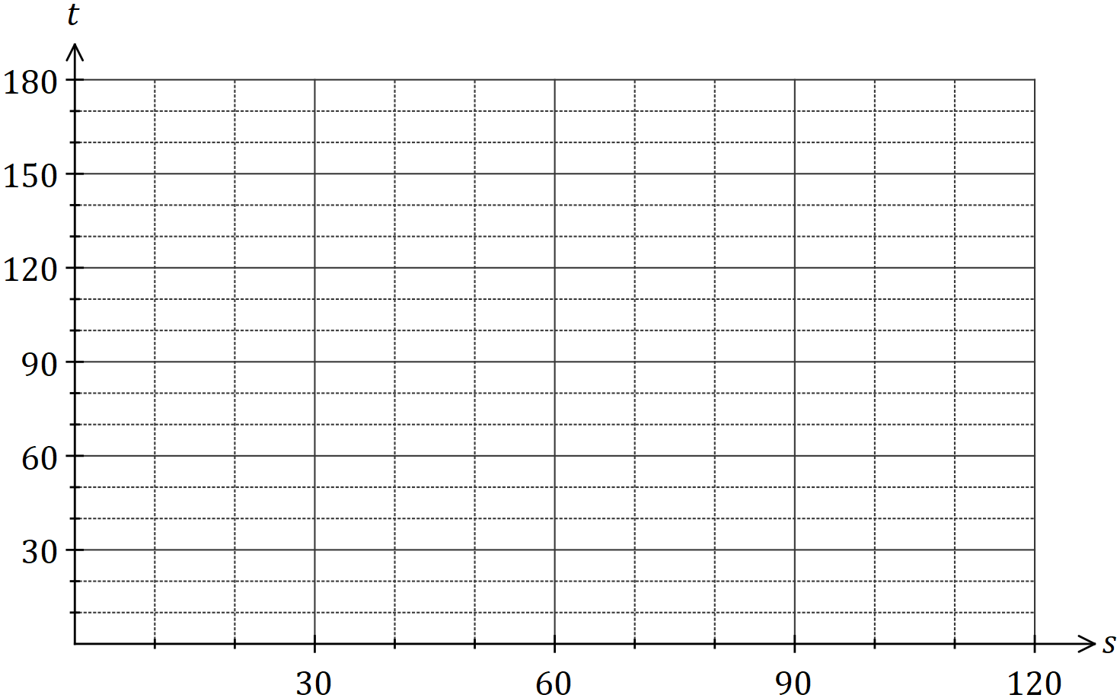

Question 11 (8 marks)

In an experiment, the sound intensity, $S$, can be modelled by $S\left(x\right)=3.6-2.4x+1.5x^{2}-0.2x^{3}$, where $x$ is the distance from the sound source in metres and $0≤x≤6$.

(a) Determine $S$ when $x=3$. (1 mark)

(b) Draw the graph of $y=S(x)$ on the axes below. (4 marks)

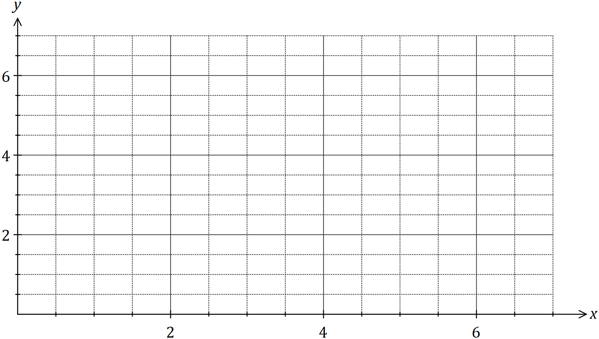

(c) Determine the equation of the straight line $L$ that passes through the $x$-intercept and the $y$-intercept of the graph of $y=S(x)$. (2 marks)

(d) Determine the coordinates of the point of intersection of $L$ with the graph of $y=S(x)$ where $x>0$ and $y>0$. (1 mark)

Question 12 (8 marks)
(a) A function is given by .
(i) State the natural domain and corresponding range of . (2 marks)

(ii) The graph of is dilated vertically by a scale factor of 2. Determine the coordinates of the -axis intercept. (2 marks)

(iii) The graph of is translated 3 units to the right. Determine the equation of the translated function. (1 mark)

(b) The graph of the cubic function $y=g(x)$ is shown below. Determine $g(10)$. (3 marks)

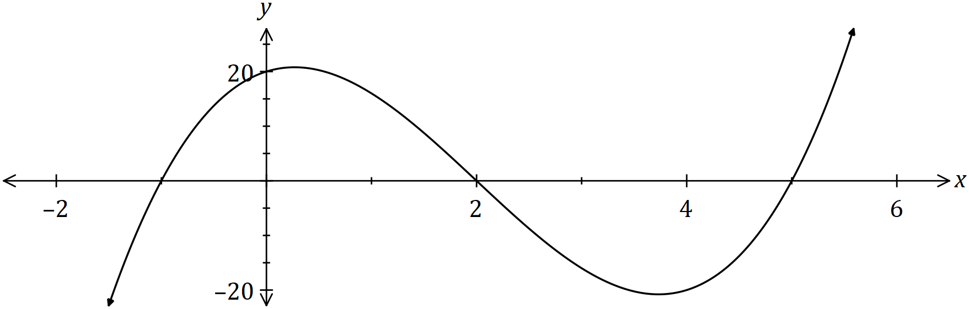

Question 13 (8 marks)
The graph of $y=f(x)$ is shown below where $f\left(x\right)=\begin{matrix}c \\ \overline{a-x}\end{matrix}$ .

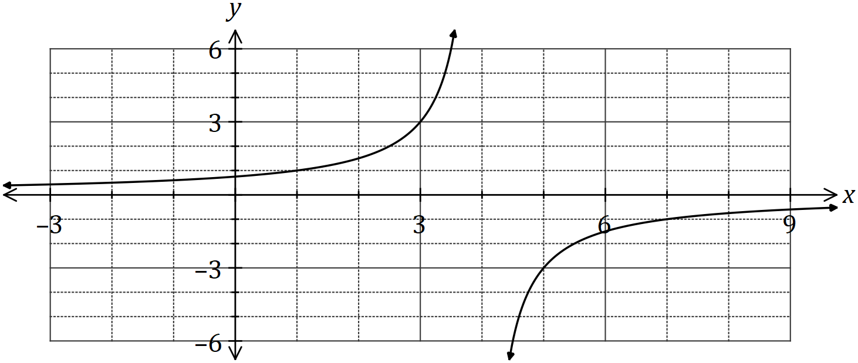

(a) State the value of the constant $a$ and the value of the constant $c$. (3 marks)

(b) The hyperbola shown above has two asymptotes. State their equations. (2 marks)

(c) Describe the transformation required to transform the graph of $y=f(x)$ to obtain the graph of $y=f(x-3)$ and state the domain and range of the transformed function. (3 marks)

Question 14 (8 marks)
(a) Convert, giving an exact answer

(i) $16°$ to radians. (1 mark)

(ii) $0.4$ radians to degrees. (1 mark)

(b) Calculate, to the nearest degree, the acute angle between the line $y=1.5x-4$ and the line $y=-0.5x+4$. (3 marks)

(c) The sides adjacent to the right-angle in a right triangle have lengths $65$ cm and $72$ cm.

If the smallest angle in the triangle is $α$, determine an exact value for

(i) $\tan{α}$. (1 mark)

(ii) $\sin{(90°-α)}$. (2 marks)

Question 15 (7 marks)
An obtuse angled triangle $ABC$ has $a=36$ cm, $c=52$ cm and an area of $748$ cm², given the length
of b is the longest length of a side of triangle ABC.

(a) Sketch a triangle to show this information. (1 mark)

(b) Determine the size of $∠B$. (2 marks)

(c) Show that $b≈79$ cm. (2 marks)

(d) Show that $∠C≈32°$. (2 marks)

Question 16 (8 marks)
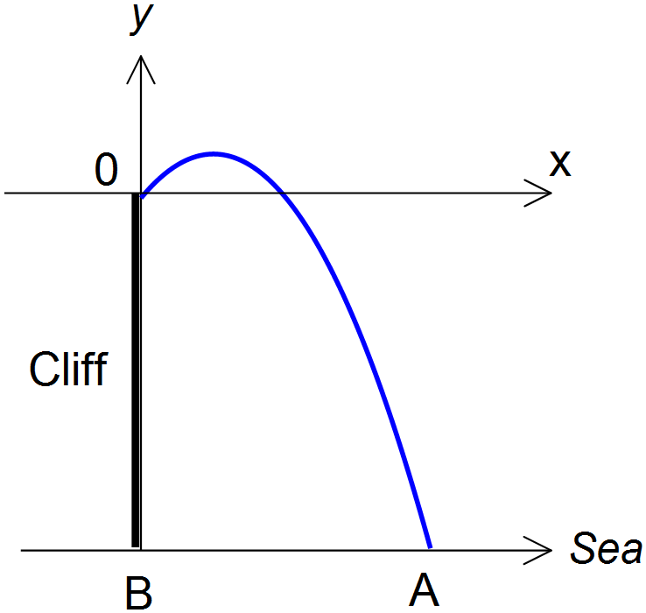A ball is thrown off the top of a cliff, 100m above sea level. Taking the point of projection O as the origin of the coordinate axes, the path taken by the ball is given as

$$y=0.1x\left(30-x\right).$$

The ball hits the surface of the sea at A.

- Find the height above sea level for the highest point reached by the ball. (2 marks)

- Find the distance from A to B, the base of the cliff. (3 marks)

- Find the horizontal distance from O, correct to one decimal place, when the ball is
110m above sea level. (3 marks)

Question 17 (7 marks)
In shape $OABCD$ below, $∠AOB=126°$ and $AC$, $BD$ are diameters of the circle with centre $O$ and radius $35$ cm.
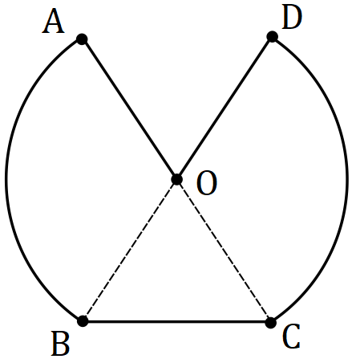

(a) Calculate the perimeter of $OABCD$. (4 marks)

(b) Calculate the area of $OABCD$. (3 marks)

Question 18 (6 marks)
Let $a=\sin{50°}$ and $b=\cos{100°}$.

Give your answers to the following in terms of $a$ and/or $b$.

(a) Write down an expression for

(i) $\sin{130°}$. (1 mark)

(ii) $\cos{80°}$. (1 mark)

(b) Determine an expression for $\cos{130°}$. (3 marks)

(c) Determine an expression for $\tan{130°}$. (1 mark)

Question 19 (8 marks)
(a) The equation of the axis of symmetry for the graph of $y=3x^{2}+6x+7$ is $x=k$. Determine the value of $k$, using a method that does not refer to the graph of the parabola.
(2 marks)

(b) A parabola with equation $y=ax^{2}+bx+c$ has a turning point at $(6, -5)$ and passes through the point $(-2, -37)$. Determine the value of $a$, the value of $b$ and the value of $c$.
(3 marks)

(c) Determine the value of the discriminant for the quadratic equation $16x^{2}-24x+9=0$ and use it to explain how many solutions the equation $\left(x+1\right)\left(16x^{2}-24x+9\right)=0$ will have.
(3 marks)

Question 20 (8 marks)
(a) The graphs of three functions,
are shown below. (6 marks)

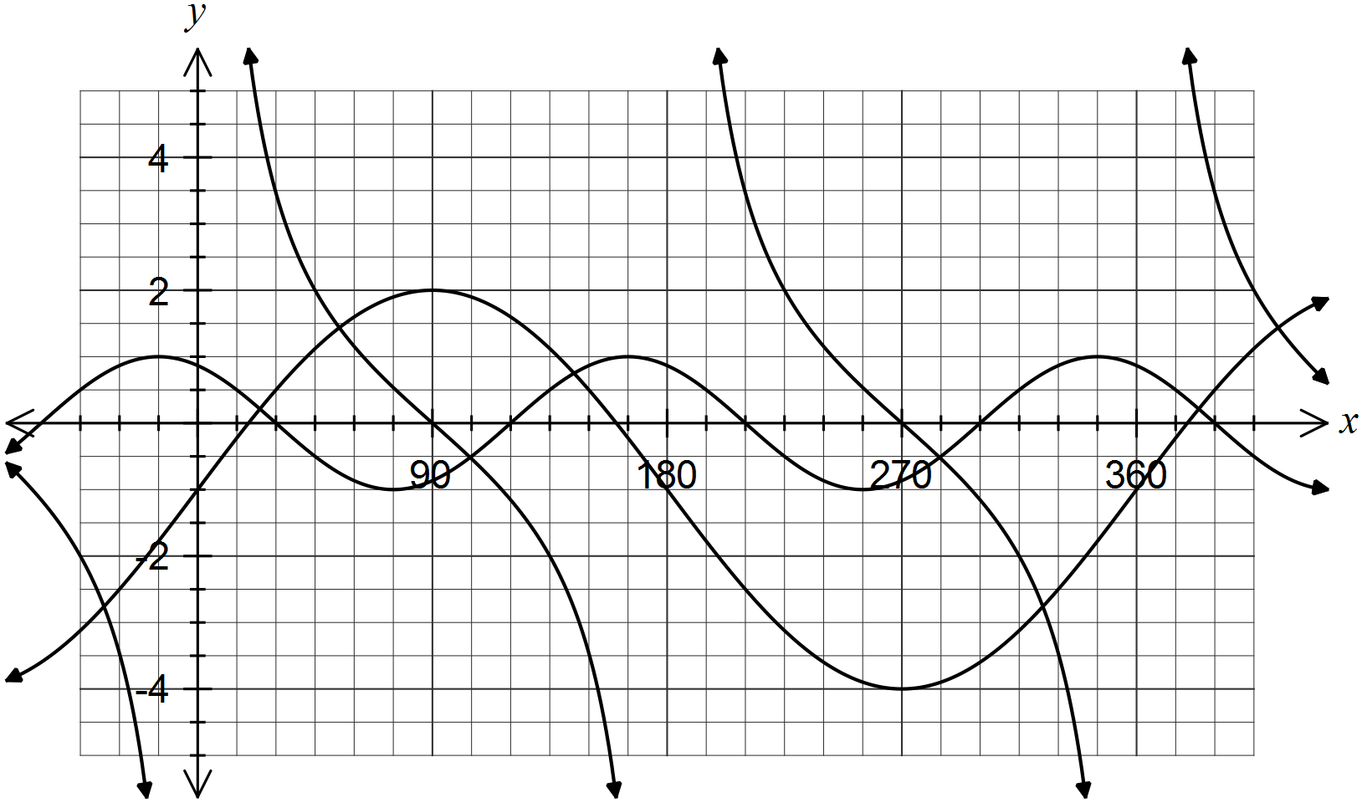

Determine the values of the real constants .

(b) Determine the equation of a line which is inclined at an angle of 120º to the positive
-axis and cuts the -axis at (0, -2). (2 marks)

Question 21 (8 marks)
(a) The circle shown has centre $O$ and diameter $AC$ of length $50$ cm. Determine the shaded area given that $2×∠AOB=3×∠BOC$. (4 marks)

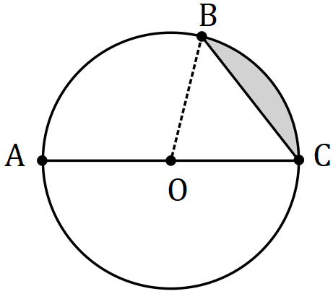

(b) A sector of a circle has a perimeter of $112$ cm and an area of $735$ cm². Determine the radius of the circle. (4 marks)

Additional working space.

Question Number: _________

